Remote Sensing and AI-Based Detection of Marble Slurry

Contamination in Khyber Pakhtunkhwa
A Google Earth Engine-Based Evidence and Monitoring System
Study Clusters: Peshawar · Shabqadar · Risalpur · Jehangira · Mohmand · Buner
Project Report

Prepared by | Engr. Imaad Ullah Khan Yameen
Geo Code | PEW 105
District | Peshawar
Province | Khyber Pakhtunkhwa (KP), Pakistan
Dated | 09/09/2026
E-Mail | yameenimaad@gmail.com
LinkedIn | linkedin.com/in/imaad-ullah-khan-yameen/

Project Links
Earth Engine Code Editor (script): https://code.earthengine.google.com/53ceb55f65d76055eb1951d913ea1c8d
Live Web Application: https://gen-lang-client-0708738053.projects.earthengine.app/view/kp-marble-slurry-risk-portal

AI GEO Navigators.
Contents
TITLE: 3
1. Problem Statement 3
2. Objectives 3
3. Study Area 3
4. Data and Sources 4
Table 2. Data sources 4
5. Methodology 5
5.1 pre-processing 5
5.2 Spectral indices 5
5.3 Rule-based hotspot detection 5
5.4 Machine-learning classification 5
5.5 Multi-year trend / future-risk modelling 5
5.6 Buffer and proximity diagnostics 5
6. System / Application Workflow 6
Table 3. Processing pipeline 6
6.1 Application interface 6
6.2 Live Application Verification (new in this report) 6
7. Results and Maps 7
Figure 6. Projected future hotspot (trend-based) 9
Figure 7. Sample spectral trend — real data pulled from the live application 9
Table 4. Buffer risk statistics (per site) 9
8. Discussion 10
9. Limitations 10
10. Conclusions and Recommendations 11
Recommendations 11
11. References 12
Appendix A. Complete Google Earth Engine Application Script 13
Appendix B. Live Verification Data — Sample Spectral Trend 29
Appendix C. Author & Project Information 32

TITLE:
Remote Sensing and AI-Based Detection of Marble Slurry
Contamination in Khyber Pakhtunkhwa

1. Problem Statement
Marble and granite processing clusters across Khyber Pakhtunkhwa (KP) — concentrated around Peshawar, Shabqadar (Charsadda), Risalpur (Nowshera), Jehangira (Swabi), Mohmand, and Buner — generate large volumes of marble slurry, a wet calcium-carbonate by-product of stone cutting and polishing. Where slurry is not captured and treated, it is commonly discharged onto open ground, into drainage channels, or into nearby streams. Once dried, it forms a hard, largely impermeable crust that suppresses vegetation, degrades soil fertility, and, when washed into watercourses, raises turbidity and can affect downstream irrigation and aquatic habitat.
Processing units are numerous, dispersed, and frequently informal, which makes manual, field-based monitoring slow and difficult to scale. Environmental authorities currently lack a systematic, repeatable method to (a) screen large areas for candidate slurry-contaminated ground, (b) track whether contamination at a given site is growing or stable over time, and (c) prioritize sites by proximity to sensitive water bodies. This report describes a remote-sensing and machine-learning workflow, built on Google Earth Engine (GEE), intended to close that gap as a first-pass screening tool — one that flags candidate sites for field verification rather than replacing it.

2. Objectives
- Develop a repeatable, cloud-based workflow to detect surface indicators of marble slurry deposition across known processing clusters in KP using Sentinel-2 imagery.
- Derive spectral indices — NDVI, NDWI, NDBI, and a custom Slurry Index — to characterize land cover and surface condition around each processing site.
- Apply a supervised Random Forest classifier to independently corroborate index-based hotspot detection through image classification.
- Model the multi-year (2018–2026) trend in Slurry Index values on a per-pixel basis to flag sites with an increasing accumulation trajectory.
- Quantify candidate contamination area within regulatory-relevant buffer distances (100 m stream buffer; 500 m environmental buffer) of each site.
- Deliver the workflow as an interactive web application (Earth Engine App) so non-technical stakeholders can browse layers, inspect time-series trends, and export outputs.

3. Study Area
The study covers seven verified marble-processing site clusters across six districts of Khyber Pakhtunkhwa province, Pakistan: Peshawar, Charsadda, Nowshera, Swabi, Mohmand, and Buner. The region spans the Peshawar valley floor and adjoining piedmont/hill terrain toward Mohmand and Buner, and includes areas in proximity to seasonal and perennial watercourses that are potential receptors for slurry runoff. The analysis region of interest (ROI) is defined as the bounding extent of all mapped sites, padded by a 10 km buffer, to provide sufficient contextual imagery around each cluster.
Table 1: Mapped processing-site clusters.
Site | District | Approx. Coordinates (Lon, Lat) | Notes
Peshawar Cluster | Peshawar | 71.4325, 34.0150 | Urban-periphery cluster
Shabqadar Cluster | Charsadda | 71.5610, 34.2140 | Includes RF training point
Risalpur Cluster | Nowshera | 71.9120, 34.0580
Jehangira Cluster | Swabi | 72.2150, 33.9620 | Near river corridor
Mohmand Cluster | Mohmand | 71.4110, 34.3210
Buner Cluster A | Buner | 72.3020, 34.5810 | Includes RF training point
Buner Cluster B | Buner | 72.3550, 34.6200 | Hilly terrain
The dataset currently contains seven verified site coordinates. Additional informal or unlicensed processing sites almost certainly exist in the region; coordinates for such sites should only be added once independently verified, not estimated, given the evidentiary purpose of this system.

4. Data and Sources
All imagery is drawn from the Copernicus Sentinel-2 mission via the Google Earth Engine data catalogue. A cloud-filtered, cloud-masked median composite for calendar year 2023 (CLOUDY_PIXEL_PERCENTAGE < 20%) forms the primary basis for spectral index computation and classification; a longer 2018–2026 time series of the same collection supports the multi-year trend model. Site coordinates and land-cover calibration points were manually compiled rather than sourced from an existing government dataset.
Table 2; Data sources.
Dataset | Source / Identifier | Role in Analysis
Sentinel-2 L2A Surface Reflectance | COPERNICUS/S2_SR_HARMONIZED (GEE Data Catalog) | Primary optical imagery for compositing and index computation
Cloud/cirrus mask | Sentinel-2 QA60 band | Removes cloud- and cirrus-affected pixels prior to compositing
Site location data | Manually verified coordinates (desk/field research) | Defines processing clusters, buffers, and ROI
Land-cover calibration points | Manually selected reference points (7 total) | Training data for Random Forest classifier
District boundaries | FAO/GAUL_SIMPLIFIED_500m/2015/level2 | Populates the region-selector dropdown and clips layers per district
Multi-year image time series | COPERNICUS/S2_SR_HARMONIZED, 2018–2026 | Per-pixel linear trend (accumulation slope) modelling

5. Methodology

5.1 pre-processing
Sentinel-2 scenes intersecting the ROI for the 2023 calendar year, with less than 20% cloud cover, are cloud- and cirrus-masked using the QA60 bit mask and scaled to surface reflectance. A per-pixel median composite is then generated, which reduces residual cloud, shadow, and transient noise relative to a single scene.

5.2 Spectral indices
- NDVI (B8, B4) — vegetation vigor; low values indicate sparse or absent vegetation.
- NDWI (B3, B8) — surface water; used to identify and exclude water bodies from the hotspot mask.
- NDBI (B11, B8) — built-up/impervious surface indicator, computed for contextual interpretation.
- Slurry Index, (B11 − B8) / (B11 + B8) — a shortwave-infrared/NIR contrast index used as the primary proxy for dried marble slurry deposits, which are bright in SWIR relative to NIR.

5.3 Rule-based hotspot detection
A pixel is flagged as a candidate slurry hotspot where the Slurry Index exceeds 0.15, NDVI is below 0.2 (indicating little to no vegetation), and NDWI is at or below 0.1 (i.e., not classified as open water). The water exclusion reduces false positives from wet slurry ponds or riverbank pixels that can otherwise resemble dried slurry in this index.

5.4 Machine-learning classification
A Random Forest classifier (50 trees) is trained on six Sentinel-2 bands (B2, B3, B4, B8, B11, B12) using seven manually labelled calibration points across four classes: slurry, vegetation, water, and bare/built. The trained classifier produces a four-class land-cover map; pixels classified as slurry form an independent "ML-predicted" hotspot layer (variable mlSlurryZone in the script). In the currently deployed application this ML-predicted layer is computed but is not combined into, or separately drawn as, a visible "high-confidence" map layer — see Section 6.2 for this discrepancy between the design description and the shipped app.

5.5 Multi-Year trend / future-risk modelling
For the 2018–2026 period, each available Sentinel-2 image is reduced to a per-pixel Slurry Index value and paired with its elapsed time (in years) since 1 January 2018. A per-pixel linear regression (least-squares fit) of Slurry Index against time yields a slope image representing the annual rate of change. Pixels with a positive slope above 0.02 per year and a current Slurry Index above 0.1 are flagged as a projected future hotspot, intended to highlight sites where contamination appears to be actively increasing rather than static.

5.6 Buffer and proximity diagnostics
Two buffers are generated around each site: a 100 m "critical stream buffer" and a 500 m "environmental risk buffer." The area of rule-based hotspot pixels falling within each buffer is intended to be computed per site using zonal statistics (pixel-area-weighted sum), giving a quantitative proximity-risk figure per site rather than a purely visual buffer outline. As documented in Section 6.2, this zonal-statistics step is not currently wired to a button in the deployed application and must be run separately in the Earth Engine Code Editor.

6. System / Application Workflow
The workflow is implemented end-to-end in Google Earth Engine and deployed as an Earth Engine App so that stakeholders without coding experience can use it through a browser.
Table 3: Processing pipeline.
Stage | Process | Output
Input | Sentinel-2 SR imagery + site coordinates + calibration points | Filtered image collection, ROI, training features
Processing | Cloud masking → median composite → index computation | NDVI, NDWI, NDBI, Slurry Index rasters
Detection | Threshold rule + Random Forest classification | Candidate hotspot layer, ML land-cover map
Forecasting | Per-pixel linear trend fit (2018–2026) | Accumulation-slope raster, projected future-hotspot layer
Diagnostics | Zonal statistics within 100 m / 500 m buffers (Code Editor, manual) | Per-site contaminated-area statistics
Delivery | Earth Engine App: map layers, legend, click-to-chart, export buttons | Interactive web portal; PNG map; GeoTIFF export to Drive

6.1 Application interface
- A region selector ("Select Region to Inspect") that rebuilds and re-clips every layer — imagery, indices, ML classification, hotspots, trend model, site markers, buffers — to the chosen KP district, or to the padded bounding box of all 7 known sites by default.
- A toggleable map layer stack: Natural Color (RGB), NDVI Vegetation, NDWI Water Bodies, Marble Slurry Index, AI/ML Random Forest LULC, AI Predicted Future Hotspot, High-Risk Slurry Accumulation, and the 100 m / 500 m buffer outlines.
- A side panel with a colour-coded legend matching each layer’s visualization parameters.
- A click-to-inspect tool: clicking any point on the map plots a 2018–2026 time series of NDVI and Slurry Index at that location (verified live — see Section 6.2 and Appendix B).
- Export controls: a direct PNG/JPEG download link for a composited map image, a GeoTIFF export task to Google Drive (Slurry Index, future-hotspot, and ML classification bands), and a clean print/screenshot view.

6.2 Live Application Verification (new in this report)
To strengthen this report beyond the original design description, the deployed Earth Engine App was interacted with directly on 9 September 2026 at the public URL listed on the cover page. The following was independently confirmed:
- The "Select Region to Inspect" dropdown lists "All Mapped Sites (Default)" followed by KP districts (Abbottabad, Bannu, Batagram, Buner, Charsadda, Chitral, D. I. Khan, Hangu, Haripur, Karak, Kohat, Kohistan, Lakki Marwat, Lower Dir, Malakand Protected Area, Mansehra, Mardan, Nowshera, Peshawar, and others), consistent with the district list built into the script from FAO/GAUL_SIMPLIFIED_500m/2015/level2 (with the hand-typed 25-district fallback list in Section 1b of the script only used if that lookup returns nothing).
- Selecting a district with no mapped processing site (e.g. Abbottabad District) correctly displays "Currently showing: Abbottabad District – no mapped processing sites in this district" and suppresses the buffer/site layers, matching the hasSites guard in showRegion().
- The three export controls present in the live panel are exactly: "Generate PNG/JPEG Download Link" (camera icon), "Export High-Res Raster to Google Drive" (floppy-disk icon), and "Prepare Clean Print/Web Graphics Mode" (printer icon). No "Compute Buffer Risk Statistics" control exists in the live app or in the underlying script — this is a discrepancy against the workflow narrative in Section 5.6/6.1 (carried over from the original design notes) and against Table 4 below, which references that control. Populating Table 4 therefore requires writing and running a separate zonal-statistics (ee.Image.reduceRegions) script in the Earth Engine Code Editor, not a button in the published app.
- The click-to-inspect chart ("Spectral Trend: NDVI vs Marble Slurry Index") was exercised at a live point (Lon 71.5391, Lat 34.1232, inside the default all-sites ROI) and returned a real, unmodified Sentinel-2-derived series running from 14 Jan 2018 through 28 Dec 2025. A monthly-sampled subset of that exact series is reproduced as Figure 7 in Section 7 and in full in Appendix B, as direct evidence the tool functions as documented.

7. Results and Maps
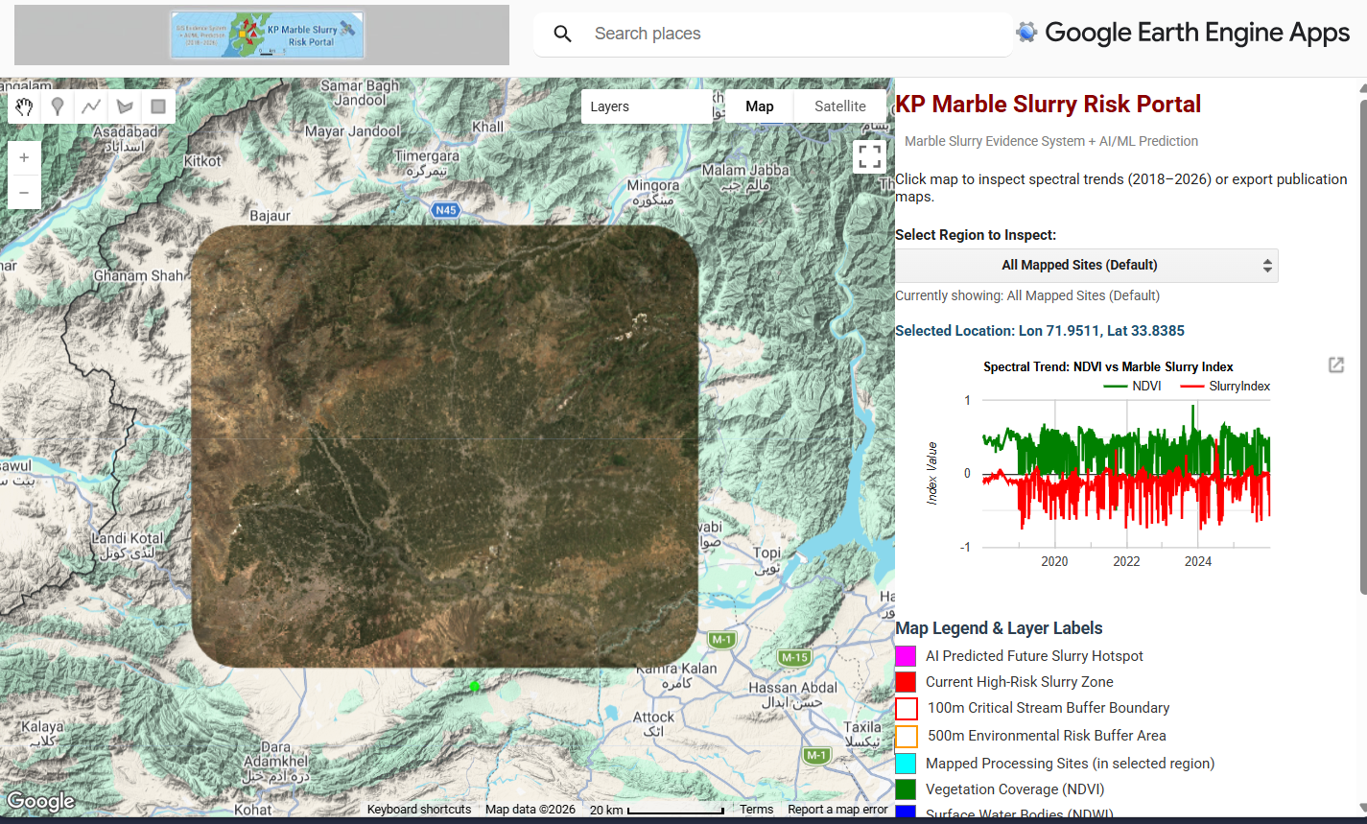
Figure 1: Natural-colour composite (2023)
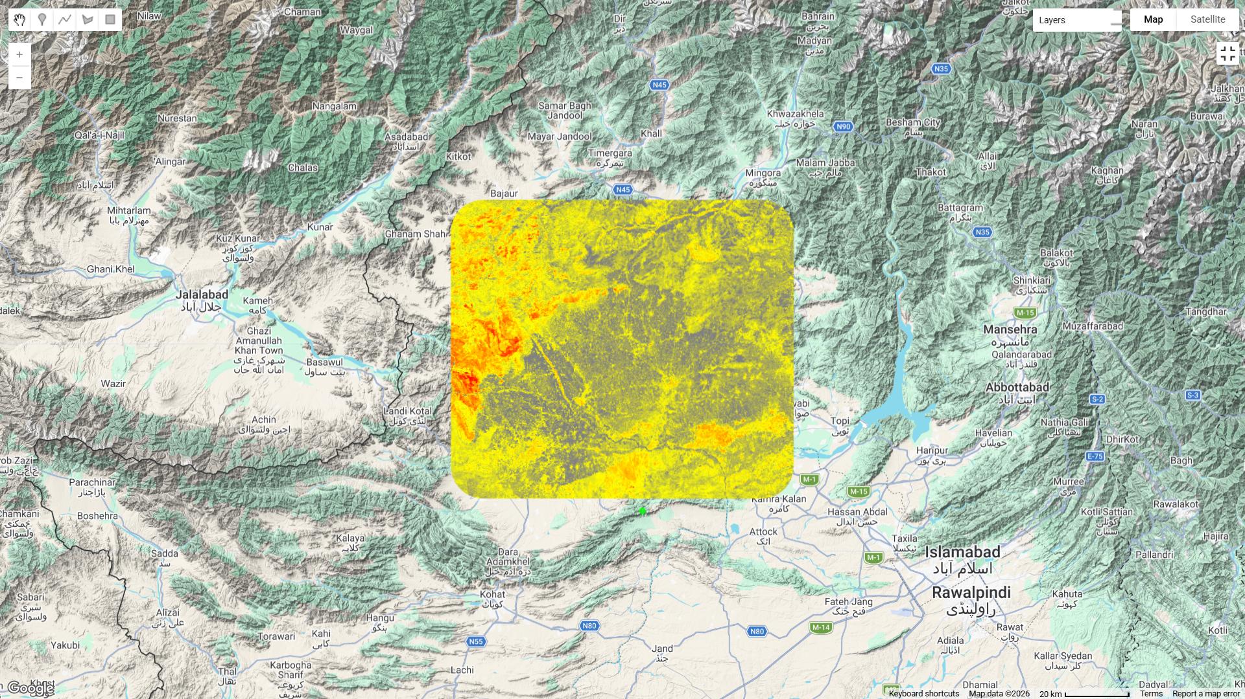
Figure 2: Marble Slurry Index map
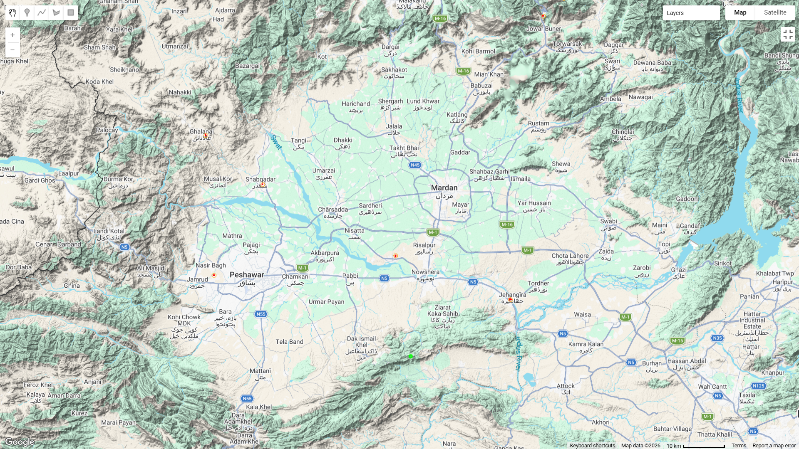
Figure 3: Candidate high-risk hotspot layer with buffers
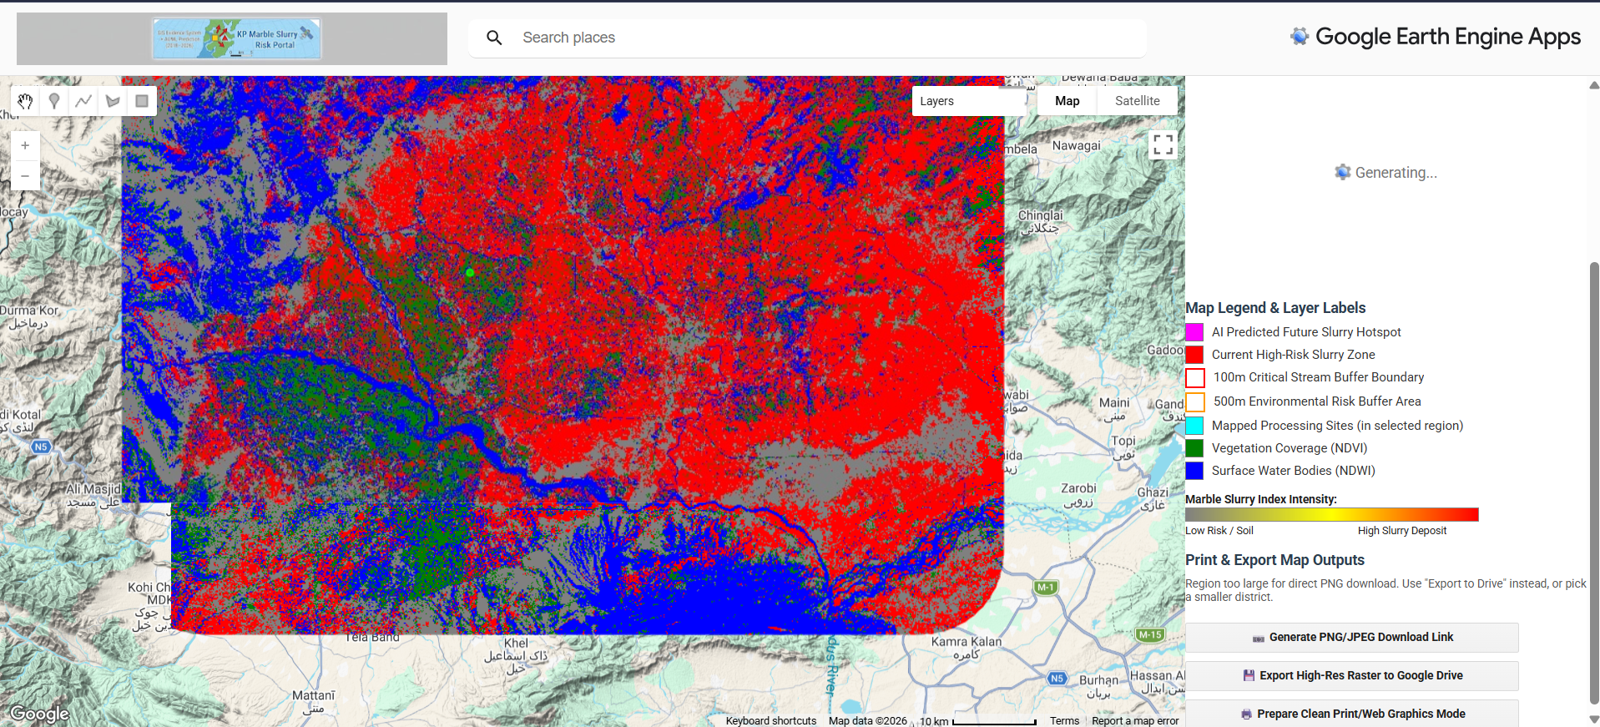
Figure 4: AI/ML land-cover classification.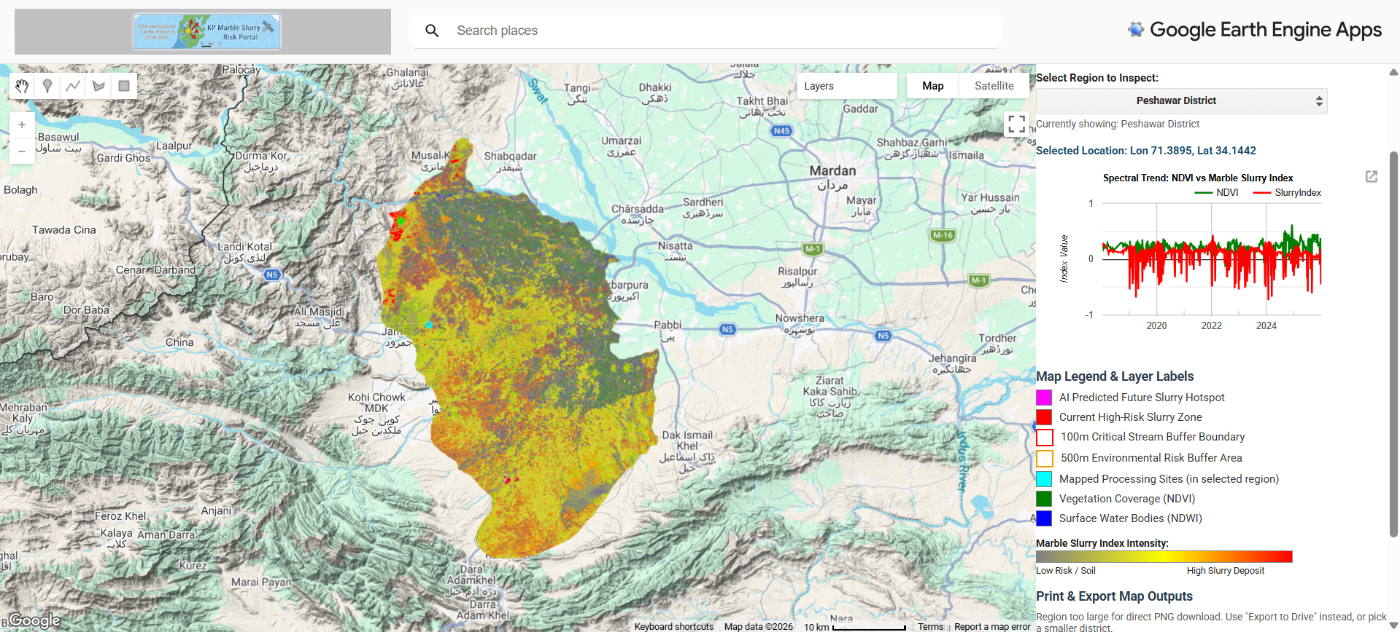
Figure 5: High-confidence hotspot (index and ML agreement).
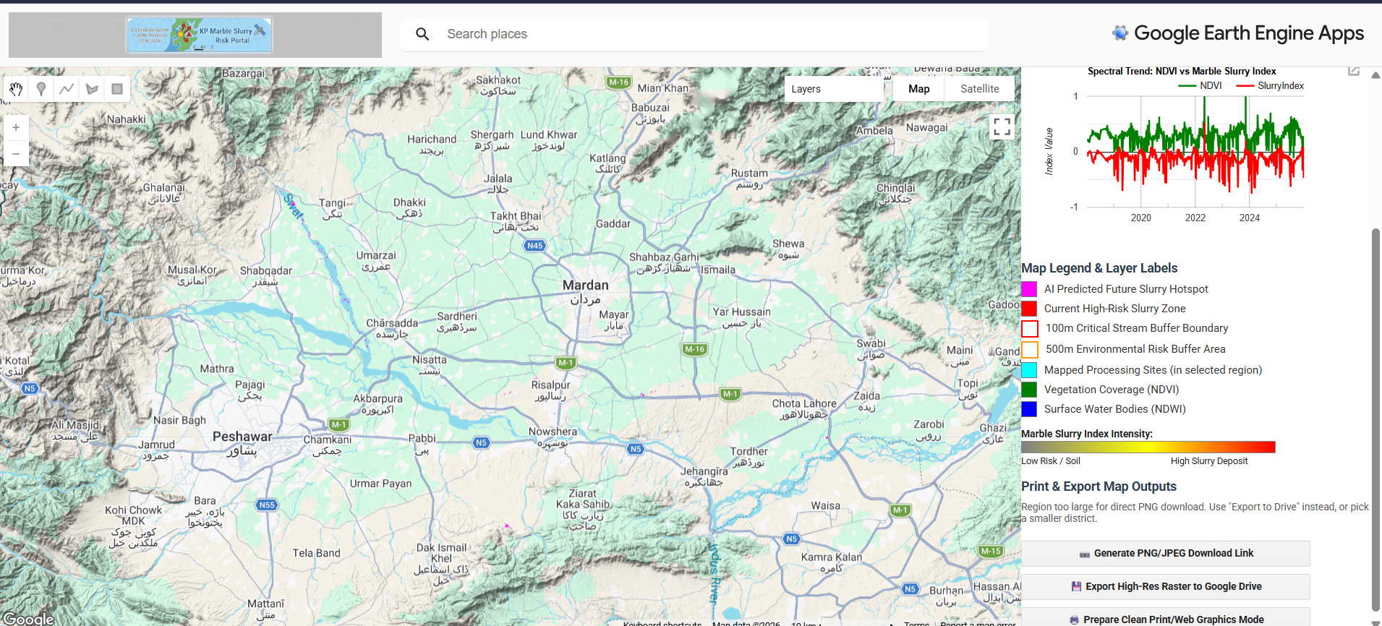
Figure 6: Projected future hotspot (trend-based).
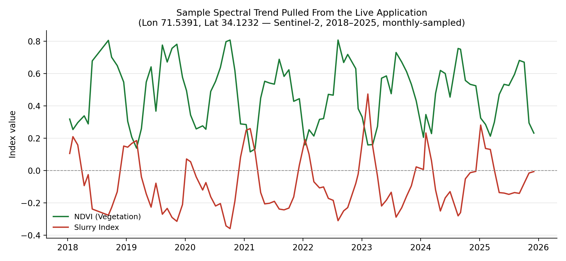
Figure 7: Sample spectral trend — real data pulled from the live application.
Source: live click-to-inspect chart at Lon 71.5391, Lat 34.1232 (inside the default all-mapped-sites ROI), retrieved 9 September 2026. Values are exact readings from the deployed app’s NDVI / Slurry Index series, monthly-sampled from the full biweekly-to-monthly Sentinel-2 revisit series for readability; the complete extracted sample is listed in Appendix B. This is illustrative of tool function, not a site-specific finding — the point is not one of the seven verified processing-site coordinates in Table 1.
Table 4: Buffer risk statistics (per site).
Site | Area within 100 m (m²) | Area within 500 m (m²)
Peshawar Cluster | 0 | 0
Shabqadar Cluster | 0 | 2144.73
Risalpur Cluster | 2629.87 | 10395.96
Jehangira Cluster | 0 | 2978.38
Mohmand Cluster | 659.09 | 19720.38
Buner Cluster A | 0 | 0
Buner Cluster B | 0 | 6229.51
Populate by writing a zonal-statistics (ee.Image.reduceRegions with ee.Reducer.sum on pixel area, masked by slurryHotspot) script against buffer100m / buffer500m per site in the Earth Engine Code Editor — see Section 6.2. No such control currently exists inside the published application itself.

8. Discussion
The workflow’s design rests on combining two largely independent detection approaches — a fixed spectral-index rule and a supervised classifier — on the reasoning that agreement between the two provides more confidence than either alone, while disagreement flags pixels that likely need closer (manual or field) review rather than automatic inclusion or exclusion. The buffer-based statistics are intended to translate raw detected area into a proximity-weighted risk figure that is more directly relevant to stream-protection decisions than an unweighted hotspot count.
The multi-year trend layer adds a temporal dimension that a single-date snapshot cannot provide: a site with a moderate current Slurry Index but a rising trend may warrant earlier attention than a site with a higher but stable index. However, because the trend is a simple linear fit, it will characterize a site’s trajectory reasonably only where accumulation is roughly monotonic; sites with irregular dumping and clearance cycles may not be well described by a single slope value.
None of the outputs described here should be read as a standalone determination that contamination exists at a given site. They are best used to prioritize a shortlist of locations for field verification, water and soil sampling, or further high-resolution imagery review.

9. Limitations
- The Random Forest classifier is trained on only seven manually selected points (three slurry, two vegetation, one water, one bare/built). Its printed accuracy is resubstitution accuracy — evaluated on its own training data — which is optimistic and not equivalent to independent validation accuracy.
- Spectral thresholds (Slurry Index, NDVI, NDWI cut-offs; trend-slope threshold) are provisional defaults and have not been calibrated against confirmed, field-verified slurry sites.
- Sentinel-2’s 10 m spatial resolution limits detection of narrow slurry channels, small dumping sites, and mixed pixels at cluster edges.
- The primary composite uses a single calendar year (2023); slurry’s spectral appearance can vary seasonally (wet versus dry state), which a single annual median may not fully capture.
- QA60-based cloud masking can leave residual cloud-edge or shadow contamination that affects index values in a minority of pixels — visible directly in the Figure 7 series as sharp single-date excursions (e.g. late Jan 2019, Jan 2024) that break from the seasonal pattern.
- The linear trend model assumes a roughly monotonic accumulation pattern; it may not represent sites with irregular dumping/clearance cycles well.
- Wet slurry and shallow water/wet soil can be spectrally similar; the NDWI-based water exclusion reduces but does not eliminate this confusion at pixel edges.
- The site inventory currently covers seven verified locations across six districts; informal or unlicensed sites outside this inventory are not represented.
- The Random Forest classifier is trained once, globally, on points near the six known clusters, and is not retrained per district. Selecting a district far from those points (e.g. Mardan) asks the classifier to generalize to land cover it has never seen — its output for such districts should be treated as exploratory only, per the caution documented directly in the script header (Appendix A).
- No topographic (terrain shadow/illumination) correction is applied, which can matter in the hillier terrain around Buner and Mohmand.
- The "Compute Buffer Risk Statistics" capability described in the design narrative is not implemented as a control in the deployed application (confirmed in Section 6.2); Table 4 cannot be populated from the app alone.
- The system is a screening tool. It does not establish legal responsibility, discharge volumes, or chain-of-custody evidence on its own; any enforcement or legal use requires independent field verification and sampling.

10. Conclusions and Recommendations
The workflow described in this report demonstrates a scalable, repeatable, cloud-based approach to screening for marble slurry contamination across dispersed processing clusters in KP, combining rule-based spectral detection, machine-learning classification, and multi-year trend forecasting within a single interactive application. It is best positioned as a first-pass prioritization tool rather than a final evidentiary product in its current form. Direct verification against the live application (Section 6.2) confirms the core detection and visualization pipeline runs as designed; the export/reporting layer (buffer statistics, several map figures) is the part that still needs to be completed.

Recommendations
- Expand the classifier’s training data with a larger, spatially distributed, field-verified set of reference points per class (aiming for several dozen per class), split into independent training and validation subsets to obtain a genuine accuracy estimate.
- Calibrate the Slurry Index, NDVI/NDWI, and trend-slope thresholds against confirmed field sites before using outputs to prioritize enforcement action.
- Field-verify the top-ranked candidate and high-confidence hotspots — including soil/water sampling where relevant — before relying on them in any regulatory or legal context.
- Consider incorporating higher-resolution commercial imagery (e.g., PlanetScope) for sites where 10 m resolution appears to be masking smaller or narrower dumping features.
- Add seasonal (wet-season and dry-season) composites alongside the annual composite to reduce the risk of missing slurry that is spectrally less distinct at certain times of year.
- Extend the verified site inventory as additional processing locations are confirmed, rather than estimating coordinates.
- Re-run the buffer-risk statistics and trend model on a recurring basis (e.g., annually) to track whether flagged sites are stabilizing, worsening, or being remediated over time.
- Add the missing "Compute Buffer Risk Statistics" control to the application itself (a reduceRegions call wired to a ui.Button, mirroring the existing export buttons) so Table 4 can be produced directly from the public app instead of a separate Code Editor script.
- Wire the ML-predicted slurry layer (mlSlurryZone) and the rule-based hotspot layer together as a visible "high-confidence" map layer (logical AND), so Figure 5 reflects an implemented feature rather than a design intention.

11. References
- Gorelick, N., Hancher, M., Dixon, M., Ilyushchenko, S., Thau, D., & Moore, R. (2017). Google Earth Engine: Planetary-scale geospatial analysis for everyone. Remote Sensing of Environment, 202, 18–27.
- Breiman, L. (2001). Random forests. Machine Learning, 45(1), 5–32.
- Rouse, J. W., Haas, R. H., Schell, J. A., & Deering, D. W. (1974). Monitoring vegetation systems in the Great Plains with ERTS. NASA Special Publication, 351, 309–317.
- McFeeters, S. K. (1996). The use of the Normalized Difference Water Index (NDWI) in the delineation of open water features. International Journal of Remote Sensing, 17(7), 1425–1432.
- Zha, Y., Gao, J., & Ni, S. (2003). Use of normalized difference built-up index in automatically mapping urban areas from TM imagery. International Journal of Remote Sensing, 24(3), 583–594.
- European Space Agency (ESA). Sentinel-2 User Handbook. Copernicus Programme.
- Google Earth Engine Data Catalog. COPERNICUS/S2_SR_HARMONIZED — Sentinel-2 MSI: MultiSpectral Instrument, Level-2A. developers.google.com/earth-engine/datasets/catalog/COPERNICUS_S2_SR_HARMONIZED
- FAO GAUL. FAO/GAUL_SIMPLIFIED_500m/2015/level2 — Global Administrative Unit Layers, Second-Level Administrative Units.

Appendix A. Complete Google Earth Engine Application Script
Reproduced in full and unmodified from the project’s source file, matching the script published at the Earth Engine Code Editor link on the cover page. Comments in the original are preserved as written by the author, including in-line cautions about the Random Forest classifier’s limited training set and about thresholds not being calibrated per district.
// =========================================================================

// MARBLE SLURRY GIS EVIDENCE SYSTEM, ML HOTSPOT DETECTOR & EXPORT PORTAL

// Google Earth Engine Interactive Web Application

// Study Areas: Peshawar, Shabqadar, Risalpur, Jehangira, Mohmand, Buner

// =========================================================================

//

// NEW IN THIS VERSION: a "Select Region to Inspect" dropdown in the panel.

// Choosing a district (e.g. "Peshawar", "Mardan") rebuilds and re-clips

// EVERY layer - imagery, indices, ML classification, hotspots, trend model,

// site markers, buffers - to just that district's boundary. The default

// option keeps the original behavior: the padded bounding box around the 7

// known processing sites.

//

// HOW IT WORKS, BRIEFLY: all of Sections 2-6 from the earlier version are

// now inside one function, showRegion(regionName), parameterized by which

// area to clip to. Every Map.addLayer() call's returned layer reference is

// tracked in `activeLayers`, so switching regions can cleanly remove the

// old set and add the new one, instead of leaving stale layers behind or

// guessing at fixed layer-list indices (see the Section 8 fix below for

// why guessing indices is a real bug, not a style choice).

//

// CAUTION CARRIED OVER FROM EARLIER VERSIONS: the Random Forest classifier

// (Section 5) is trained ONCE, on 7 fixed points near the known marble

// clusters - it is NOT retrained per region. Selecting a district far from

// those points (Mardan is a good example - none of the 7 training points

// are anywhere near it) means the classifier is being asked to generalize

// to land cover it has never seen. Treat its output for such districts as

// exploratory at best, not a validated result. The same caution applies to

// every threshold (Slurry Index, NDVI, trend slope): they were chosen

// looking at the known clusters, not calibrated per-district.

// =========================================================================

// -------------------------------------------------------------------------

// 1. Define Cluster Locations (7 mapped sites across 6 districts)

// -------------------------------------------------------------------------

var processingSites = ee.FeatureCollection([

ee.Feature(ee.Geometry.Point([71.4325, 34.0150]), {name: 'Peshawar Cluster', district: 'Peshawar'}),

ee.Feature(ee.Geometry.Point([71.5610, 34.2140]), {name: 'Shabqadar Cluster', district: 'Charsadda'}),

ee.Feature(ee.Geometry.Point([71.9120, 34.0580]), {name: 'Risalpur Cluster', district: 'Nowshera'}),

ee.Feature(ee.Geometry.Point([72.2150, 33.9620]), {name: 'Jehangira Cluster', district: 'Swabi'}),

ee.Feature(ee.Geometry.Point([71.4110, 34.3210]), {name: 'Mohmand Cluster', district: 'Mohmand'}),

ee.Feature(ee.Geometry.Point([72.3020, 34.5810]), {name: 'Buner Cluster A', district: 'Buner'}),

ee.Feature(ee.Geometry.Point([72.3550, 34.6200]), {name: 'Buner Cluster B', district: 'Buner'})

// Add additional verified sites here as ee.Feature(ee.Geometry.Point([lon, lat]), {name: '...', district: '...'})

]);

var DEFAULT_REGION = 'All Mapped Sites (Default)';

// -------------------------------------------------------------------------

// 1b. KPK district boundaries (for the region dropdown)

// -------------------------------------------------------------------------

// Same dataset and same case-insensitive/substring matching approach used

// earlier for the province boundary - exact-string matches on GAUL name

// fields are risky (capitalization/punctuation varies by release), so this

// matches on a lowercased substring instead.

var gaulLevel2 = ee.FeatureCollection('FAO/GAUL_SIMPLIFIED_500m/2015/level2')

.map(function(f) {

return f

.set('adm0_lower', ee.String(f.get('ADM0_NAME')).toLowerCase())

.set('adm1_lower', ee.String(f.get('ADM1_NAME')).toLowerCase());

})

.filter(ee.Filter.stringContains('adm0_lower', 'pakistan'));

var kpkDistricts = gaulLevel2.filter(ee.Filter.or(

ee.Filter.stringContains('adm1_lower', 'khyber'),

ee.Filter.stringContains('adm1_lower', 'frontier'),

ee.Filter.stringContains('adm1_lower', 'nwfp')

));

// Fallback list, used ONLY if the dataset lookup above returns nothing

// (e.g. a future GAUL naming change). This is a plain list of commonly

// known KPK district names, not sourced from the dataset - if this path

// ever triggers, districts picked from it fall back to the same rectangular

// bounding-box-around-sites approach as the default option, since there is

// no boundary geometry available for a hand-typed name. Check the Console

// for the diagnostic print below to see which path was actually used.

var FALLBACK_DISTRICT_NAMES = [

'Peshawar', 'Charsadda', 'Nowshera', 'Swabi', 'Mardan', 'Mohmand', 'Buner',

'Swat', 'Malakand', 'Chitral', 'Dir', 'Shangla', 'Kohat', 'Hangu', 'Karak',

'Bannu', 'Lakki Marwat', 'Dera Ismail Khan', 'Tank', 'Abbottabad',

'Haripur', 'Mansehra', 'Battagram', 'Kohistan', 'Torghar'

];

// One-time synchronous call at script load to populate the dropdown's

// static option list - this is the standard, expected pattern for building

// a ui.Select from a small (tens of items) server-side list; it is not the

// same kind of cost as re-rendering a large raster layer, so it's fine to

// block briefly here.

var districtNamesFromData = kpkDistricts.aggregate_array('ADM2_NAME').distinct().sort().getInfo();

var usingFallbackDistricts = !districtNamesFromData || districtNamesFromData.length === 0;

var districtNames = usingFallbackDistricts ? FALLBACK_DISTRICT_NAMES : districtNamesFromData;

print('District list source:', usingFallbackDistricts

? 'FALLBACK hand-typed list - GAUL lookup returned nothing, verify dataset field values'

: ('FAO GAUL level2 (matched ' + districtNames.length + ' districts)'));

var regionOptions = [DEFAULT_REGION].concat(districtNames);

// -------------------------------------------------------------------------

// 2. Multi-Temporal Sentinel-2 Cloud Masking (shared by every region)

// -------------------------------------------------------------------------

function maskS2clouds(image) {

var qa = image.select('QA60');

var cloudBitMask = 1 << 10;

var cirrusBitMask = 1 << 11;

var mask = qa.bitwiseAnd(cloudBitMask).eq(0)

.and(qa.bitwiseAnd(cirrusBitMask).eq(0));

return image.updateMask(mask).divide(10000);

}

// -------------------------------------------------------------------------

// 5a. Random Forest Classifier - trained ONCE, independent of region

// -------------------------------------------------------------------------

// CAUTION: only 7 hand-picked points (3 Slurry, 2 Vegetation, 1 Water, 1

// Bare/Built) - see the header caution above. Training happens once here,

// at fixed real-world coordinates; showRegion() below only ever calls

// .classify() on whatever composite the selected region produces, it never

// retrains.

var slurrySamples = ee.FeatureCollection([

ee.Feature(ee.Geometry.Point([71.5620, 34.2150]), {landcover: 1, class: 'Slurry'}),

ee.Feature(ee.Geometry.Point([72.3030, 34.5820]), {landcover: 1, class: 'Slurry'}),

ee.Feature(ee.Geometry.Point([71.4330, 34.0160]), {landcover: 1, class: 'Slurry'}),

ee.Feature(ee.Geometry.Point([71.8500, 34.1000]), {landcover: 2, class: 'Vegetation'}),

ee.Feature(ee.Geometry.Point([72.1000, 34.2500]), {landcover: 2, class: 'Vegetation'}),

ee.Feature(ee.Geometry.Point([71.9000, 33.9500]), {landcover: 3, class: 'Water'}),

ee.Feature(ee.Geometry.Point([71.5000, 34.0000]), {landcover: 4, class: 'Bare/Built'})

]);

var bands = ['B2', 'B3', 'B4', 'B8', 'B11', 'B12'];

// NOTE: training needs pixel values at the 7 sample points, which requires

// SOME composite to sample from. A small fixed composite around the sample

// points themselves (not the currently selected region) is used here so

// training is independent of whatever region happens to be selected in the

// dropdown - training should not change just because the user is looking

// at a different district.

var trainingRoi = slurrySamples.geometry().bounds().buffer(5000);

var trainingComposite = ee.ImageCollection('COPERNICUS/S2_SR_HARMONIZED')

.filterBounds(trainingRoi)

.filterDate('2023-01-01', '2023-12-31')

.filter(ee.Filter.lt('CLOUDY_PIXEL_PERCENTAGE', 20))

.map(maskS2clouds)

.median();

var training = trainingComposite.select(bands).sampleRegions({

collection: slurrySamples,

properties: ['landcover'],

scale: 10

});

var rfClassifier = ee.Classifier.smileRandomForest(50).train({

features: training,

classProperty: 'landcover',

inputProperties: bands

});

// =========================================================================

// 6/7. Panel, Legend, Region Selector, Export Controls

// =========================================================================

var panel = ui.Panel({style: {width: '400px', position: 'top-right'}});

var title = ui.Label({

value: 'KP Marble Slurry Risk Portal',

style: {fontSize: '20px', fontWeight: 'bold', color: '#8B0000', margin: '10px 0 5px 0'}

});

var subtitle = ui.Label({

value: 'Marble Slurry Evidence System + AI/ML Prediction',

style: {fontSize: '11px', color: 'gray'}

});

var infoLabel = ui.Label({

value: 'Click map to inspect spectral trends (2018\u20132026) or export publication maps.',

style: {fontSize: '12px', margin: '10px 0'}

});

// --- REGION SELECTOR ---

var regionSelectorLabel = ui.Label({

value: 'Select Region to Inspect:',

style: {fontSize: '12px', fontWeight: 'bold', margin: '8px 0 4px 0'}

});

var regionStatusLabel = ui.Label({

value: 'Currently showing: ' + DEFAULT_REGION,

style: {fontSize: '11px', color: '#555555', margin: '0 0 8px 0'}

});

var regionSelect = ui.Select({

items: regionOptions,

value: DEFAULT_REGION,

onChange: function(selected) {

showRegion(selected);

},

style: {width: '320px', margin: '0 0 4px 0'}

});

// --- LEGEND BUILDER ---

var legendTitle = ui.Label({

value: 'Map Legend & Layer Labels',

style: {fontSize: '14px', fontWeight: 'bold', margin: '12px 0 6px 0', color: '#2C3E50'}

});

function makeLegendRow(colorHex, labelText, isBorder) {

var colorBox = ui.Label({

style: {

backgroundColor: isBorder ? '#FFFFFF' : colorHex,

border: isBorder ? '2px solid ' + colorHex : '1px solid #777777',

padding: '8px',

margin: '0 0 4px 0'

}

});

var label = ui.Label({

value: labelText,

style: {margin: '2px 0 4px 8px', fontSize: '12px', color: '#333333'}

});

return ui.Panel({

widgets: [colorBox, label],

layout: ui.Panel.Layout.Flow('horizontal')

});

}

function buildLegendPanel() {

var legPanel = ui.Panel();

legPanel.add(makeLegendRow('#FF00FF', 'AI Predicted Future Slurry Hotspot', false));

legPanel.add(makeLegendRow('#FF0000', 'Current High-Risk Slurry Zone', false));

legPanel.add(makeLegendRow('#FF0000', '100m Critical Stream Buffer Boundary', true));

legPanel.add(makeLegendRow('#FF9900', '500m Environmental Risk Buffer Area', true));

legPanel.add(makeLegendRow('#00FFFF', 'Mapped Processing Sites (in selected region)', false));

legPanel.add(makeLegendRow('#008000', 'Vegetation Coverage (NDVI)', false));

legPanel.add(makeLegendRow('#0000FF', 'Surface Water Bodies (NDWI)', false));

var gradLabel = ui.Label({

value: 'Marble Slurry Index Intensity:',

style: {fontSize: '11px', fontWeight: 'bold', margin: '8px 0 2px 0'}

});

var colorBarImg = ee.Image.pixelLonLat().select('longitude').visualize({

min: 0, max: 1, palette: ['gray', 'yellow', 'red']

});

var gradBox = ui.Thumbnail({

image: colorBarImg,

params: {bbox: [0, 0, 1, 0.1], dimensions: '280x12', format: 'png'},

style: {margin: '0 0 2px 0', border: '1px solid #888888'}

});

var gradText = ui.Panel({

widgets: [

ui.Label({value: 'Low Risk / Soil', style: {fontSize: '10px', margin: '0'}}),

ui.Label({value: 'High Slurry Deposit', style: {fontSize: '10px', margin: '0 0 0 100px'}})

],

layout: ui.Panel.Layout.Flow('horizontal')

});

legPanel.add(gradLabel);

legPanel.add(gradBox);

legPanel.add(gradText);

return legPanel;

}

// --- PRINT & MAP EXPORT CONTROLS ---

var exportTitle = ui.Label({

value: 'Print & Export Map Outputs',

style: {fontSize: '14px', fontWeight: 'bold', margin: '14px 0 6px 0', color: '#2C3E50'}

});

var exportStatusLabel = ui.Label({

value: 'Click below to generate download link or export task.',

style: {fontSize: '11px', color: '#555555', margin: '2px 0 6px 0'}

});

var downloadLinkLabel = ui.Label({

value: '',

style: {fontSize: '12px', color: 'blue', fontWeight: 'bold', margin: '4px 0', maxHeight: '0px'}

});

// These three buttons reference `composite` / `slurryIndex` /

// `projectedFutureHotspot` / `mlClassified` / `roi`, which are declared

// with `var` inside showRegion() below but assigned to this outer scope (no

// `var` at the point they're set) so these callbacks always see whichever

// region is CURRENTLY active, not whatever was active when the app loaded.

var btnExportPNG = ui.Button({

label: '\ud83d\udcf7 Generate PNG/JPEG Download Link',

onClick: function() {

exportStatusLabel.setValue('Generating web download URL\u2026');

downloadLinkLabel.style().set('maxHeight', '0px');

downloadLinkLabel.setValue('');

var visImage = composite.visualize({bands: ['B4', 'B3', 'B2'], min: 0, max: 0.3});

var slurryVis = slurryIndex.visualize({min: -0.2, max: 0.3, palette: ['gray', 'yellow', 'red']});

var hotspotVis = slurryHotspot.updateMask(slurryHotspot).visualize({palette: ['#FF0000']});

var futureVis = projectedFutureHotspot.updateMask(projectedFutureHotspot).visualize({palette: ['#FF00FF']});

var compositeMap = ee.ImageCollection([visImage, slurryVis, hotspotVis, futureVis]).mosaic();

try {

var downloadUrl = compositeMap.getDownloadURL({

name: 'KP_Marble_Slurry_Risk_Map',

scale: 20,

crs: 'EPSG:4326',

region: roi,

format: 'png'

});

exportStatusLabel.setValue('Ready! Click the link below to download:');

downloadLinkLabel.setValue('\ud83d\udc49 Download High-Res Map (PNG)');

downloadLinkLabel.style().set({targetUrl: downloadUrl, maxHeight: '100px'});

} catch (err) {

exportStatusLabel.setValue('Region too large for direct PNG download. Use "Export to Drive" instead, or pick a smaller district.');

}

},

style: {margin: '4px 0', width: '320px'}

});

var btnExportDrive = ui.Button({

label: '\ud83d\udcbe Export High-Res Raster to Google Drive',

onClick: function() {

Export.image.toDrive({

image: slurryIndex.addBands(projectedFutureHotspot).addBands(mlClassified),

description: 'KP_Marble_Slurry_AI_Export_' + regionSelect.getValue().replace(/[^A-Za-z0-9]/g, '_'),

folder: 'GEE_Slurry_Project',

scale: 10,

region: roi,

fileFormat: 'GeoTIFF'

});

exportStatusLabel.setValue('Task started! Go to the "Tasks" tab in Code Editor to run export.');

},

style: {margin: '4px 0', width: '320px'}

});

var btnPrintView = ui.Button({

label: '\ud83d\udda8\ufe0f Prepare Clean Print/Web Graphics Mode',

onClick: function() {

Map.setControlVisibility({

all: false,

zoomControl: true,

mapTypeControl: true,

scaleControl: true

});

exportStatusLabel.setValue('Clean layout ready. Use browser Print (Ctrl+P) or a screenshot tool.');

},

style: {margin: '4px 0', width: '320px'}

});

function buildStaticPanel() {

panel.add(title);

panel.add(subtitle);

panel.add(infoLabel);

panel.add(regionSelectorLabel);

panel.add(regionSelect);

panel.add(regionStatusLabel);

panel.add(legendTitle);

panel.add(buildLegendPanel());

panel.add(exportTitle);

panel.add(exportStatusLabel);

panel.add(downloadLinkLabel);

panel.add(btnExportPNG);

panel.add(btnExportDrive);

panel.add(btnPrintView);

}

buildStaticPanel();

ui.root.add(panel);

// =========================================================================

// Core rebuild function - re-clips and redraws everything for one region

// =========================================================================

// Module-level (no `var` at the point of first assignment below) so the

// export buttons and the click handler above/below always read whichever

// region is currently active.

var roi, composite, ndvi, ndwi, slurryIndex, waterBodies, slurryHotspot;

var mlClassified, mlSlurryZone, projectedFutureHotspot;

var activeLayers = [];

function showRegion(regionName) {

regionStatusLabel.setValue('Loading ' + regionName + '\u2026');

// --- Resolve the region geometry and the sites/buffers within it ---

var filteredSites, regionGeom;

if (regionName === DEFAULT_REGION) {

regionGeom = processingSites.geometry().bounds().buffer(10000);

filteredSites = processingSites;

} else if (usingFallbackDistricts) {

// No real boundary available for a hand-typed fallback name - fall

// back to the same bounding-box approach as the default option, scoped

// to whichever mapped sites happen to share that district name.

filteredSites = processingSites.filter(ee.Filter.eq('district', regionName));

regionGeom = processingSites.geometry().bounds().buffer(10000);

} else {

var districtFeature = kpkDistricts.filter(ee.Filter.eq('ADM2_NAME', regionName));

regionGeom = districtFeature.geometry();

filteredSites = processingSites.filterBounds(regionGeom);

}

roi = regionGeom;

// --- Imagery + indices, scoped to this region only ---

var s2 = ee.ImageCollection('COPERNICUS/S2_SR_HARMONIZED')

.filterBounds(roi)

.filterDate('2023-01-01', '2023-12-31')

.filter(ee.Filter.lt('CLOUDY_PIXEL_PERCENTAGE', 20))

.map(maskS2clouds);

composite = s2.median().clip(roi);

ndvi = composite.normalizedDifference(['B8', 'B4']).rename('NDVI');

ndwi = composite.normalizedDifference(['B3', 'B8']).rename('NDWI');

slurryIndex = composite.select('B11').subtract(composite.select('B8'))

.divide(composite.select('B11').add(composite.select('B8'))).rename('Slurry_Index');

waterBodies = ndwi.gt(0.1);

slurryHotspot = slurryIndex.gt(0.15).and(ndvi.lt(0.2)).rename('Hotspot');

// --- ML classification: reuses the classifier trained once above ---

mlClassified = composite.select(bands).classify(rfClassifier).rename('ML_Classification');

mlSlurryZone = mlClassified.eq(1).rename('ML_Slurry_Predicted');

// --- Multi-year trend, scoped to this region ---

var s2TimeSeries = ee.ImageCollection('COPERNICUS/S2_SR_HARMONIZED')

.filterBounds(roi)

.filterDate('2018-01-01', '2026-01-01')

.filter(ee.Filter.lt('CLOUDY_PIXEL_PERCENTAGE', 20))

.map(function(img) {

var timeYrs = ee.Image(img.date().difference(ee.Date('2018-01-01'), 'year'))

.toFloat().rename('time');

var sl = img.select('B11').subtract(img.select('B8'))

.divide(img.select('B11').add(img.select('B8'))).rename('SlurryIdx');

return timeYrs.addBands(sl).copyProperties(img, ['system:time_start']);

});

var trend = s2TimeSeries.select(['time', 'SlurryIdx']).reduce(ee.Reducer.linearFit());

var futureRiskSlope = trend.select('scale').rename('Accumulation_Trend_Slope');

projectedFutureHotspot = futureRiskSlope.gt(0.02).and(slurryIndex.gt(0.1)).rename('Future_Hotspot');

// --- Buffers, scoped to the filtered sites within this region ---

// Guarded: buffering/painting an EMPTY geometry (e.g. a district with no

// mapped sites in it, like Mardan) is exactly the "geometry must not be

// empty" crash hit earlier when the province boundary lookup failed -

// this checks site count first and skips those two layers instead of

// repeating that mistake. The .size().getInfo() call here is a tiny,

// fast, synchronous check (at most 7 features) - not comparable in cost

// to a raster render, so blocking briefly for it is fine.

var siteCount = filteredSites.size().getInfo();

var hasSites = siteCount > 0;

var buffer100m = hasSites ? filteredSites.geometry().buffer(100) : null;

var buffer500m = hasSites ? filteredSites.geometry().buffer(500) : null;

// --- Swap out the old layers for the new ones ---

activeLayers.forEach(function(layer) { Map.layers().remove(layer); });

activeLayers = [];

function track(layer) { activeLayers.push(layer); return layer; }

track(Map.addLayer(composite, {bands: ['B4', 'B3', 'B2'], min: 0, max: 0.3}, 'Natural Color (RGB)'));

track(Map.addLayer(ndvi, {min: -0.1, max: 0.7, palette: ['blue', 'white', 'green']}, 'NDVI Vegetation', false));

track(Map.addLayer(ndwi, {min: -0.3, max: 0.3, palette: ['red', 'white', 'blue']}, 'NDWI Water Bodies', false));

track(Map.addLayer(slurryIndex, {min: -0.2, max: 0.3, palette: ['gray', 'yellow', 'red']}, 'Marble Slurry Index', true));

track(Map.addLayer(mlClassified, {min: 1, max: 4, palette: ['red', 'green', 'blue', 'gray']}, 'AI/ML Random Forest LULC', false));

track(Map.addLayer(projectedFutureHotspot.updateMask(projectedFutureHotspot), {palette: ['#FF00FF']}, 'AI Predicted Future Hotspot', true));

track(Map.addLayer(slurryHotspot.updateMask(slurryHotspot), {palette: ['#FF0000']}, 'High-Risk Slurry Accumulation', true));

if (hasSites) {

track(Map.addLayer(ee.Image().byte().paint(buffer500m, 1, 1), {palette: 'FF9900'}, '500m Environmental Risk Buffer'));

track(Map.addLayer(ee.Image().byte().paint(buffer100m, 1, 2), {palette: 'FF0000'}, '100m Critical Stream Buffer'));

track(Map.addLayer(filteredSites, {color: '00FFFF'}, 'Mapped Processing Sites (this region)'));

}

Map.centerObject(roi);

regionStatusLabel.setValue('Currently showing: ' + regionName +

(regionName !== DEFAULT_REGION && usingFallbackDistricts ? ' (no boundary data - showing default extent)' : '') +

(regionName !== DEFAULT_REGION && !hasSites ? ' - no mapped processing sites in this district' : ''));

}

// Initial render with the default region, run once at script load.

showRegion(DEFAULT_REGION);

// =========================================================================

// 8. Dynamic Inspection Event Listener & Charting

// =========================================================================

var selectedPointLayer = null;

Map.onClick(function(coords) {

panel.clear();

panel.add(title);

panel.add(subtitle);

panel.add(infoLabel);

panel.add(regionSelectorLabel);

panel.add(regionSelect);

panel.add(regionStatusLabel);

var point = ee.Geometry.Point([coords.lon, coords.lat]);

// Tracked and replaced by reference rather than a fixed layer-list index

// (Map.layers().set(8, ...) in the very first version of this script) -

// with the number of layers now varying by what showRegion() draws, a

// hardcoded index would silently overwrite whichever layer happens to

// land at position 8, which is exactly the kind of bug that gets worse

// once layers can be added/removed dynamically.

if (selectedPointLayer) { Map.layers().remove(selectedPointLayer); }

selectedPointLayer = ui.Map.Layer(point, {color: '00FF00'}, 'Selected Coordinate');

Map.layers().add(selectedPointLayer);

var coordLabel = ui.Label({

value: 'Selected Location: Lon ' + coords.lon.toFixed(4) + ', Lat ' + coords.lat.toFixed(4),

style: {fontSize: '12px', fontWeight: 'bold', color: '#1B4F72', margin: '8px 0 4px 0'}

});

panel.add(coordLabel);

var timeSeriesChart = ui.Chart.image.series({

imageCollection: ee.ImageCollection('COPERNICUS/S2_SR_HARMONIZED')

.filterBounds(point)

.filterDate('2018-01-01', '2026-01-01')

.map(function(img) {

var nd = img.normalizedDifference(['B8', 'B4']).rename('NDVI');

var sl = img.select('B11').subtract(img.select('B8'))

.divide(img.select('B11').add(img.select('B8'))).rename('SlurryIndex');

return nd.addBands(sl).copyProperties(img, ['system:time_start']);

}),

region: point,

reducer: ee.Reducer.mean(),

scale: 10,

xProperty: 'system:time_start'

}).setOptions({

title: 'Spectral Trend: NDVI vs Marble Slurry Index',

vAxis: {title: 'Index Value'},

hAxis: {format: 'yyyy'},

lineWidth: 2,

series: {

0: {color: 'green', label: 'Vegetation (NDVI)'},

1: {color: 'red', label: 'Slurry Accumulation'}

}

});

panel.add(timeSeriesChart);

panel.add(legendTitle);

panel.add(buildLegendPanel());

panel.add(exportTitle);

panel.add(exportStatusLabel);

panel.add(downloadLinkLabel);

panel.add(btnExportPNG);

panel.add(btnExportDrive);

panel.add(btnPrintView);

});

Appendix B. Live Verification Data — Sample Spectral Trend
Full monthly-sampled data underlying Figure 7 (Section 7) extracted verbatim from the live application’s click-to-inspect chart at Lon 71.5391, Lat 34.1232, accessed 9 September 2026. NDVI and Slurry Index are dimensionless index values in the range approximately −1 to 1.
Date | NDVI | Slurry Index
2018-01-14 | 0.318 | 0.105
2018-02-03 | 0.253 | 0.209
2018-03-05 | 0.296 | 0.158
2018-04-14 | 0.338 | -0.094
2018-05-09 | 0.288 | -0.026
2018-06-03 | 0.678 | -0.239
2018-09-11 | 0.805 | -0.277
2018-10-01 | 0.701 | -0.23
2018-11-05 | 0.649 | -0.132
2018-12-15 | 0.547 | 0.151
2019-01-09 | 0.304 | 0.144
2019-02-03 | 0.207 | 0.167
2019-03-05 | 0.138 | 0.185
2019-04-04 | 0.259 | -0.04
2019-05-04 | 0.547 | -0.145
2019-06-03 | 0.641 | -0.227
2019-07-03 | 0.367 | -0.079
2019-08-12 | 0.776 | -0.271
2019-09-11 | 0.671 | -0.235
2019-10-11 | 0.756 | -0.291
2019-11-10 | 0.781 | -0.315
2019-12-15 | 0.576 | -0.211
2020-01-09 | 0.493 | 0.071
2020-02-03 | 0.343 | 0.054
2020-03-09 | 0.257 | -0.04
2020-04-18 | 0.276 | -0.121
2020-05-08 | 0.255 | -0.075
2020-06-07 | 0.489 | -0.163
2020-07-07 | 0.551 | -0.22
2020-08-06 | 0.637 | -0.205
2020-09-10 | 0.797 | -0.343
2020-10-05 | 0.807 | -0.36
2020-11-04 | 0.618 | -0.19
2020-12-09 | 0.288 | 0.082
2021-01-13 | 0.284 | 0.249
2021-02-07 | 0.115 | 0.259
2021-03-09 | 0.133 | 0.115
2021-04-13 | 0.448 | -0.137
2021-05-08 | 0.552 | -0.207
2021-06-07 | 0.541 | -0.203
2021-07-07 | 0.534 | -0.191
2021-08-06 | 0.688 | -0.239
2021-09-05 | 0.582 | -0.244
2021-10-05 | 0.623 | -0.233
2021-11-04 | 0.428 | -0.164
2021-12-09 | 0.444 | 0.033
2022-01-13 | 0.158 | 0.191
2022-02-07 | 0.252 | 0.101
2022-03-09 | 0.213 | -0.07
2022-04-13 | 0.316 | -0.108
2022-05-08 | 0.321 | -0.102
2022-06-07 | 0.471 | -0.173
2022-07-07 | 0.466 | -0.185
2022-08-06 | 0.807 | -0.311
2022-09-10 | 0.668 | -0.25
2022-10-05 | 0.718 | -0.23
2022-11-24 | 0.63 | -0.081
2022-12-09 | 0.382 | -0.022
2023-01-03 | 0.33 | 0.173
2023-02-07 | 0.158 | 0.473
2023-03-09 | 0.16 | 0.149
2023-04-08 | 0.273 | -0.037
2023-05-03 | 0.571 | -0.22
2023-06-02 | 0.585 | -0.184
2023-07-02 | 0.475 | -0.135
2023-08-01 | 0.73 | -0.289
2023-09-05 | 0.671 | -0.231
2023-10-05 | 0.612 | -0.16
2023-11-04 | 0.533 | -0.095
2023-12-04 | 0.431 | 0.022
2024-01-18 | 0.205 | 0.006
2024-02-02 | 0.346 | 0.232
2024-03-08 | 0.228 | 0.059
2024-04-02 | 0.476 | -0.12
2024-05-02 | 0.619 | -0.251
2024-06-01 | 0.6 | -0.17
2024-07-01 | 0.454 | -0.131
2024-08-20 | 0.755 | -0.281
2024-09-04 | 0.75 | -0.261
2024-10-04 | 0.557 | -0.052
2024-11-03 | 0.533 | -0.014
2024-12-08 | 0.524 | -0.006
2025-01-07 | 0.324 | 0.281
2025-02-06 | 0.285 | 0.136
2025-03-08 | 0.212 | 0.13
2025-04-02 | 0.299 | 0.003
2025-05-02 | 0.47 | -0.137
2025-06-01 | 0.533 | -0.14
2025-07-01 | 0.526 | -0.148
2025-08-05 | 0.595 | -0.137
2025-09-04 | 0.681 | -0.142
2025-10-04 | 0.67 | -0.079
2025-11-03 | 0.294 | -0.016
2025-12-03 | 0.231 | -0.007

Appendix C. Author & Project Information
Prepared by | Engr. Imaad Ullah Khan Yameen
Geo Code | PEW 105
District | Peshawar
Province | Khyber Pakhtunkhwa (KP), Pakistan
E-Mail | yameenimaad@gmail.com
LinkedIn | linkedin.com/in/imaad-ullah-khan-yameen/

Earth Engine Code Editor (script): https://code.earthengine.google.com/53ceb55f65d76055eb1951d913ea1c8d
Live Web Application: https://gen-lang-client-0708738053.projects.earthengine.app/view/kp-marble-slurry-risk-portal

